**NOTE: This is an official document by Indexademics. Unless otherwise stated, this document may not be accredited to individuals or groups other than the club IDX, nor should this document be distributed, sold, or modified for personal use in any way.**

**IDX G9 MATH S+ STUDY GUIDE ISSUE 6**

**By Aiden and Julie**

**Contents:**

1. ***9-1 Translations***
2. ***9-2 Reflection***
3. ***9-3 Rotation***
4. ***9-6 Compositions of Reflections***
5. ***9-4 Symmetry***
6. ***9-6 Dilations***
7. ***9-1 Translations***

* **Definition of a Translation (Slide):**
  + A translation is an isometry (a transformation that preserves distances) that moves all points of a figure the same distance in the same direction.
* **Composition of Translations:**
  + A composition of translations is the result of applying two or more translations in sequence.
* A translation can be written as ((x, y) (x + a, y + b)).
* For a figure like (triangle ABC), the image after translation is denoted as (triangle A’B’C’), where (A’), (B’), and (C’) are the new positions of points (A), (B), and (C).

1. ***9-2 Reflection***
2. **New Term**

**·*Reflection***

**A reflection is an isometry in which a figure and its image have opposite orientation.**

**All reflection has its own reflection line.**

**·*how to draw reflection***

**1 .Draw lines perpendicular to the reflection line, passing through the points.**

**2 .Measure the distance from the points to the reflection line.**

**3 .Mark the reflected point on the opposite side of the line at the same distance.**

**4 .Connect the Reflected Points**

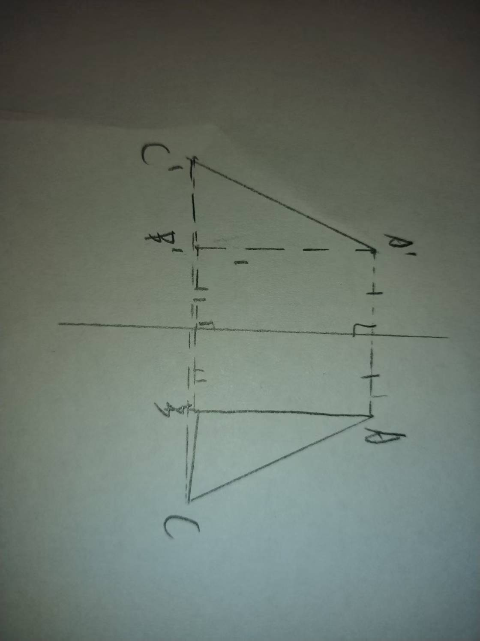

**E.g.**

**·*some universal law of reflection***

|  |  |  |  |
| --- | --- | --- | --- |
| **The form of reflection line** | **Transformation formula** | **Example** | **Orientation change** |
| **X=a** | (*x*,*y*)→(2*a*−*x*,*y*) | (3,4)→(5,4) (if *a*=4) | Left-right flipped |
| *y*=*b* | (*x*,*y*)→(*x*,2*b*−*y*) | (2,5)→(2,−1) (if *b*=2) | Up-down flipped |
| *y*=*x* | (*x*,*y*)→(*y*,*x*) | (4,7)→(7,4) | Swapped coordinates |
| *y*=−*x* | (*x*,*y*)→(−*y*,−*x*) | |  | | --- | | (2,3)→(−3,−2) | | Swapped & negated coordinates |

1. ***9-3 Rotation***
2. **New terms**

**·*Rotation***

**Rotation is a transformation that turns a figure around a fixed point by a specified angle and direction.**

**·*the center of rotation***

The **center of rotation** is the fixed point about which a figure is rotated. Every point on the figure moves along a circular path around this point during rotation.

**·*the angle of rotation***

The **angle of rotation** is the measure (in degrees or radians) by which a figure is turned around the center of rotation. It determines how "far" the figure rotates.

**·*clockwise & counterclockwise***

Rotation in the **same direction/opposite** as the movement of a clock’s hands (↷/↶). Mathematically, this is a negative/positive angle.

1. **How to draw rotation**

**1 .Locate the center of rotation**

**2 .Turn each point by the angle of rotation in clockwise/counterclockwise(as counterclockwise if not mentioned)**

**3 .Connect the points to complete image**

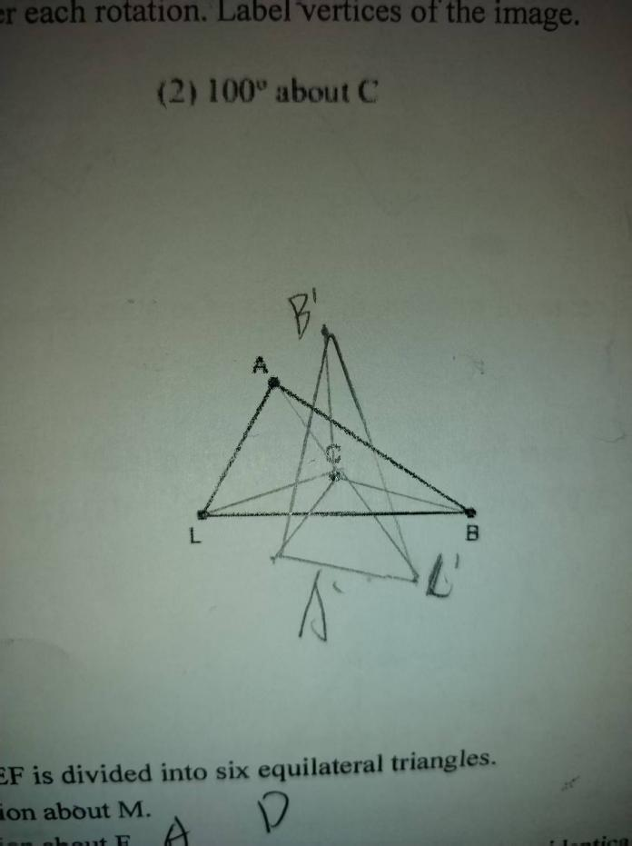

**E.g.**

1. **How to find the center of rotation**

**1 .Select two pairs of points (original and rotated).**

**2 .Draw two segments connecting original and rotated points**

**3 .Construct a perpendicular bisector of each segment**

**4 .The connected point of two perpendicular bisectors is the center of rotation**

**9.4 Symmetry**

Symmetry refers to a figure that can be mapped onto itself by a transformation (reflection or rotation).

Review Questions

1. Types of Symmetry:
   * Line/Reflectional Symmetry: A figure can be reflected over a line to map onto itself.
   * Rotational Symmetry: A figure can be rotated around a point (less than360) to map onto itself.
   * Point Symmetry: A 180 rotation maps the figure onto itself.
2. Draw Lines of Symmetry:
   * (1) Isosceles Trapezoid: 1 line of symmetry.
   * (2) Square: 4 lines of symmetry.
   * (3) Regular Pentagon: 5 lines of symmetry.
   * (4) Parallelogram: 0 lines (unless it’s a square or rhombus).
3. Rotational Symmetry:
   * Regular ( n )-gon: ( n ) lines of symmetry, rotational symmetry of 360
   * Example: Pentagon (( n = 5 )) has 72 rotational symmetry.
4. Identify Symmetry in Objects:
   * (1) Ping Pong Paddle: Rotational symmetry (yes).
   * (2) Mug: No symmetry.
   * (3) Umbrella: Rotational symmetry (yes).
   * (4) Eagle: No symmetry.

Symmetry Examples

* Letter Symmetry:
  + Letter ( V ): 1 line of symmetry, no rotational symmetry.
  + Letter ( H ): 2 lines of symmetry
  + Letter ( A ): 1 line of symmetry, no rotational symmetry.
  + Letter ( I ): 2 lines of symmetry

**9.5 Dilations**

A dilation is a transformation that changes the size of a figure (enlargement or reduction) with a center and a scale factor.

Review Questions

1. Enlargement Dimensions:
2. Similarity and Scale Factor:
3. Dilation Coordinates:

* Dilation Rules:
  + For center ( O(0, 0) ), scale factor ( s ):
    - ( (x, y) to (sx, sy) ).

Key Formulas and Rules

* Rotation:
  + ( 90 ) counterclockwise: ( (x, y) to (-y, x) ).
  + ( 180): ( (x, y) to (-x, -y) ).
* Reflection:
  + Across ( y = x ): ( (x, y) \to (y, x) ).
  + Across ( y = -x ): ( (x, y) \to (-y, -x) ).
* Dilation:
  + With center ( (h, k) ), scale factor ( s ): ( (x, y) to (h + s(x - h), k + s(y - k)) ).
* Symmetry:
  + Regular ( n )-gon: ( n ) lines of symmetry, rotational symmetry of 360/n